ASSIGNMENT NO.3: Conditional Queries and Data Filtering

Student Name | Amit Panorekar | Roll Number | 20968
Batch | SY. BSc Data Science | Topic | WB(Assignment-3)

Q1) Create a database named CollegeDB and a table named Student.
The table should contain the following columns:
Column Name | Data Type | Constraint
StudentID | INT | PRIMARY KEY
StudentName | VARCHAR(50)
Age | INT
Course | VARCHAR(30)
City | VARCHAR(30)
Marks | INT
Email | VARCHAR(60)

Insert at least 10 records into the table. Some records should contain NULL values in the Email column.

QUERY:
CREATE DATABASE JuniorCollegeDB;
USE JuniorCollegeDB;

CREATE TABLE Student (
StudentID INT PRIMARY KEY,
StudentName VARCHAR(50),
Age INT,
Course VARCHAR(30),
City VARCHAR(30),
Marks INT,
Email VARCHAR(60)
);

INSERT INTO Student (StudentID, StudentName, Age, Course, City, Marks, Email) VALUES
(1, 'Aarav Shah', 18, 'BSc IT', 'Mumbai', 85, 'aarav@email.com'),
(2, 'Meera Joshi', 19, 'BCA', 'Pune', 75, NULL),
(3, 'Rohan Patil', 20, 'BSc IT', 'Nashik', 92, 'rohan@email.com'),
(4, 'Ananya Desai', 19, 'BSc', 'Mumbai', 81, 'ananya@email.com'),
(5, 'Karan Mehta', 21, 'BCA', 'Pune', 68, NULL),
(6, 'Neha Sharma', 18, 'BSc IT', 'Mumbai', 88, 'neha@email.com'),
(7, 'Aditya Verma', 20, 'BSc', 'Nashik', 72, NULL),
(8, 'Priya Singh', 19, 'BCA', 'Pune', 95, 'priya@email.com'),
(9, 'Rahul Rao', 21, 'BSc IT', 'Mumbai', 79, 'rahul@email.com'),
(10, 'Sneha Iyer', 20, 'BSc', 'Nashik', 84, NULL);

OUTPUT:
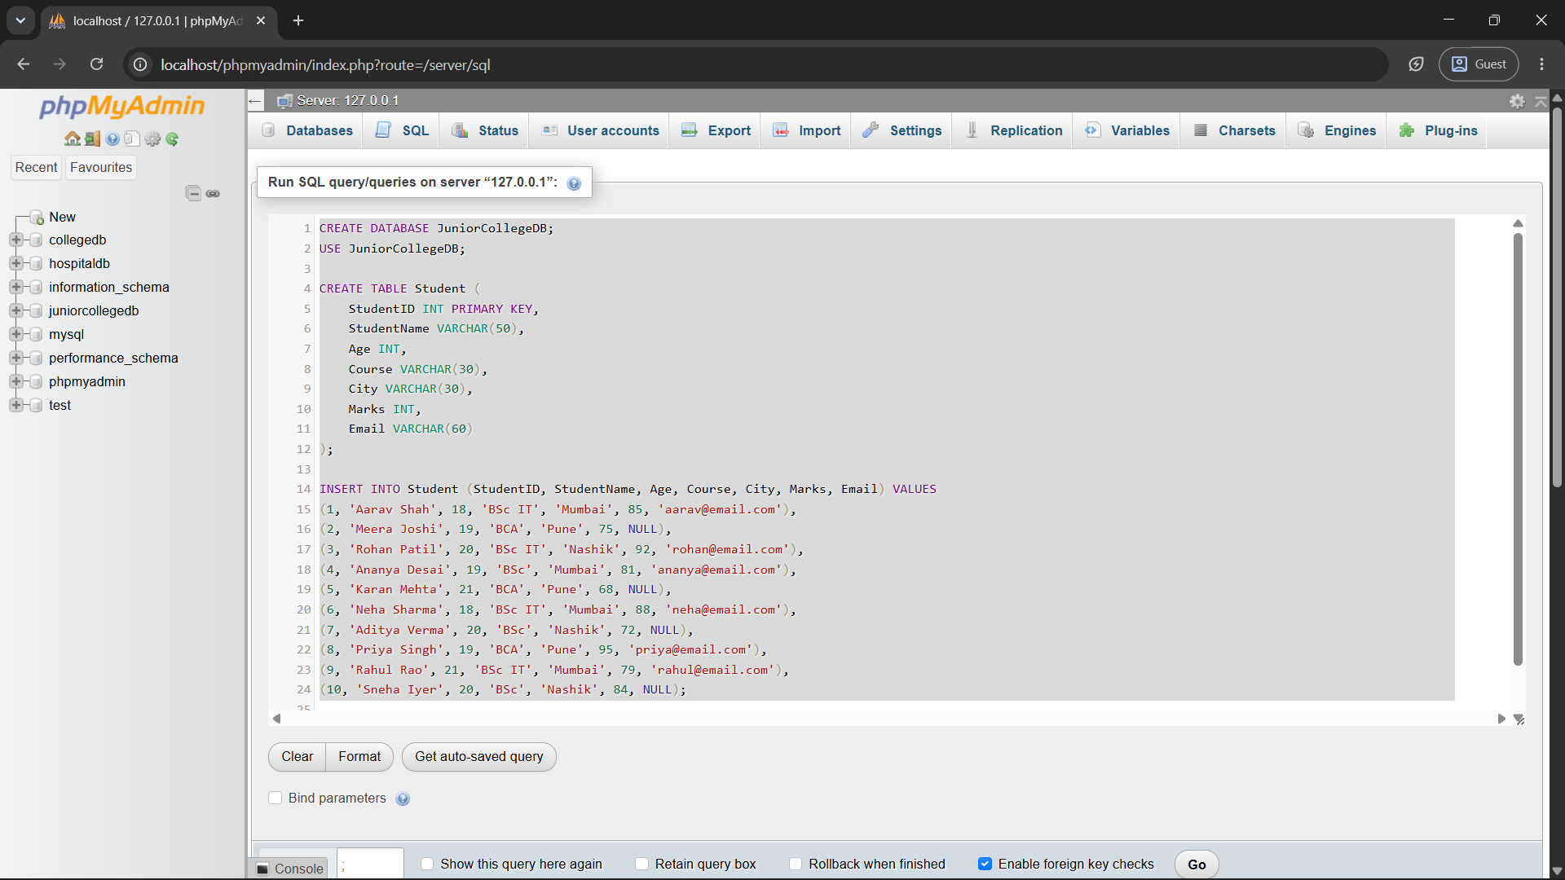
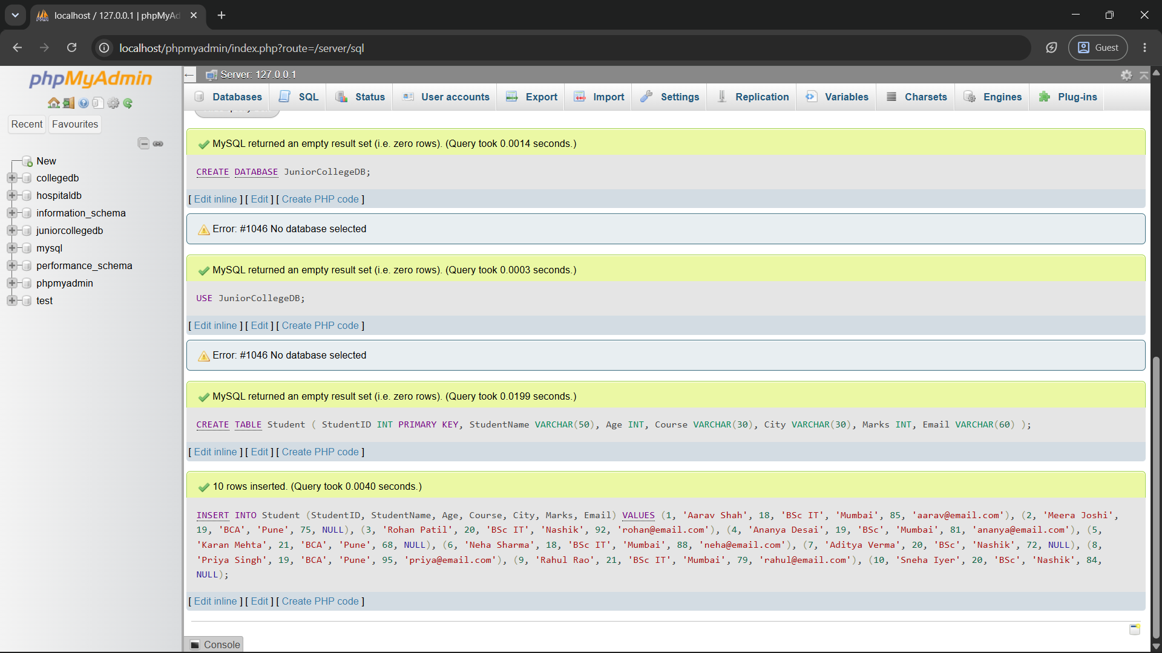
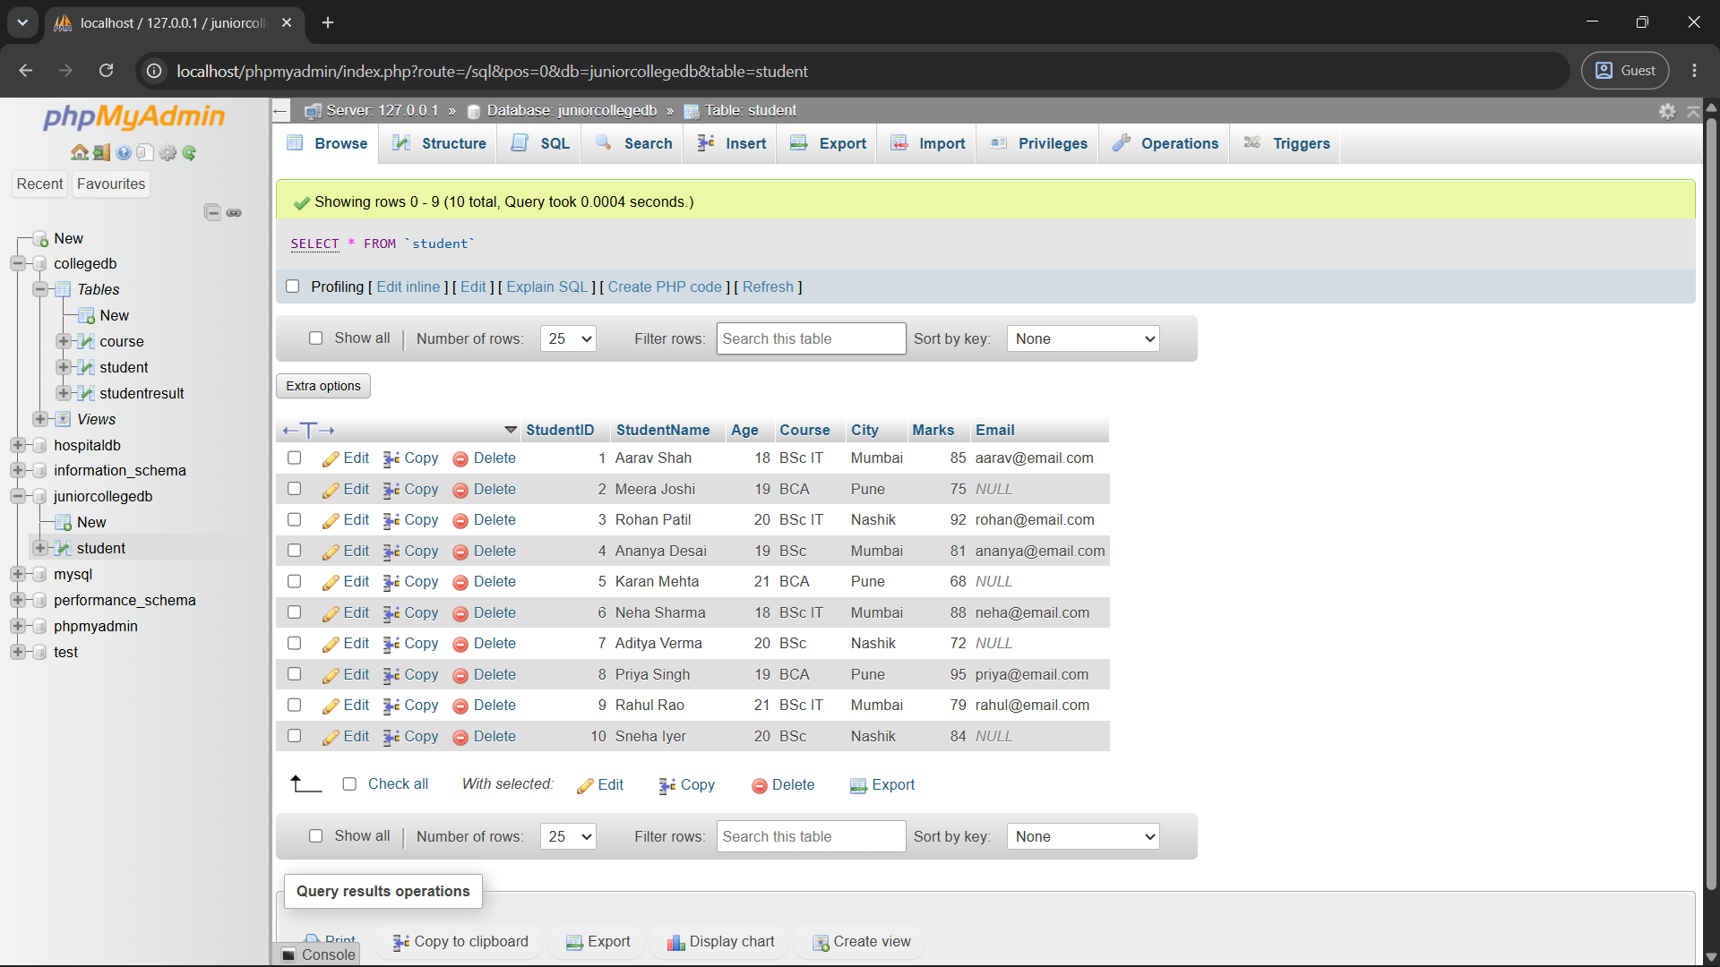

Q2) Write a MySQL query to display students who are from Mumbai and have marks greater than 80.

The output should include:
Column
StudentID
StudentName
City
Marks

QUERY:
SELECT StudentID, StudentName, City, Marks
FROM student
WHERE City = 'Mumbai'
AND Marks > 80;
OUTPUT:
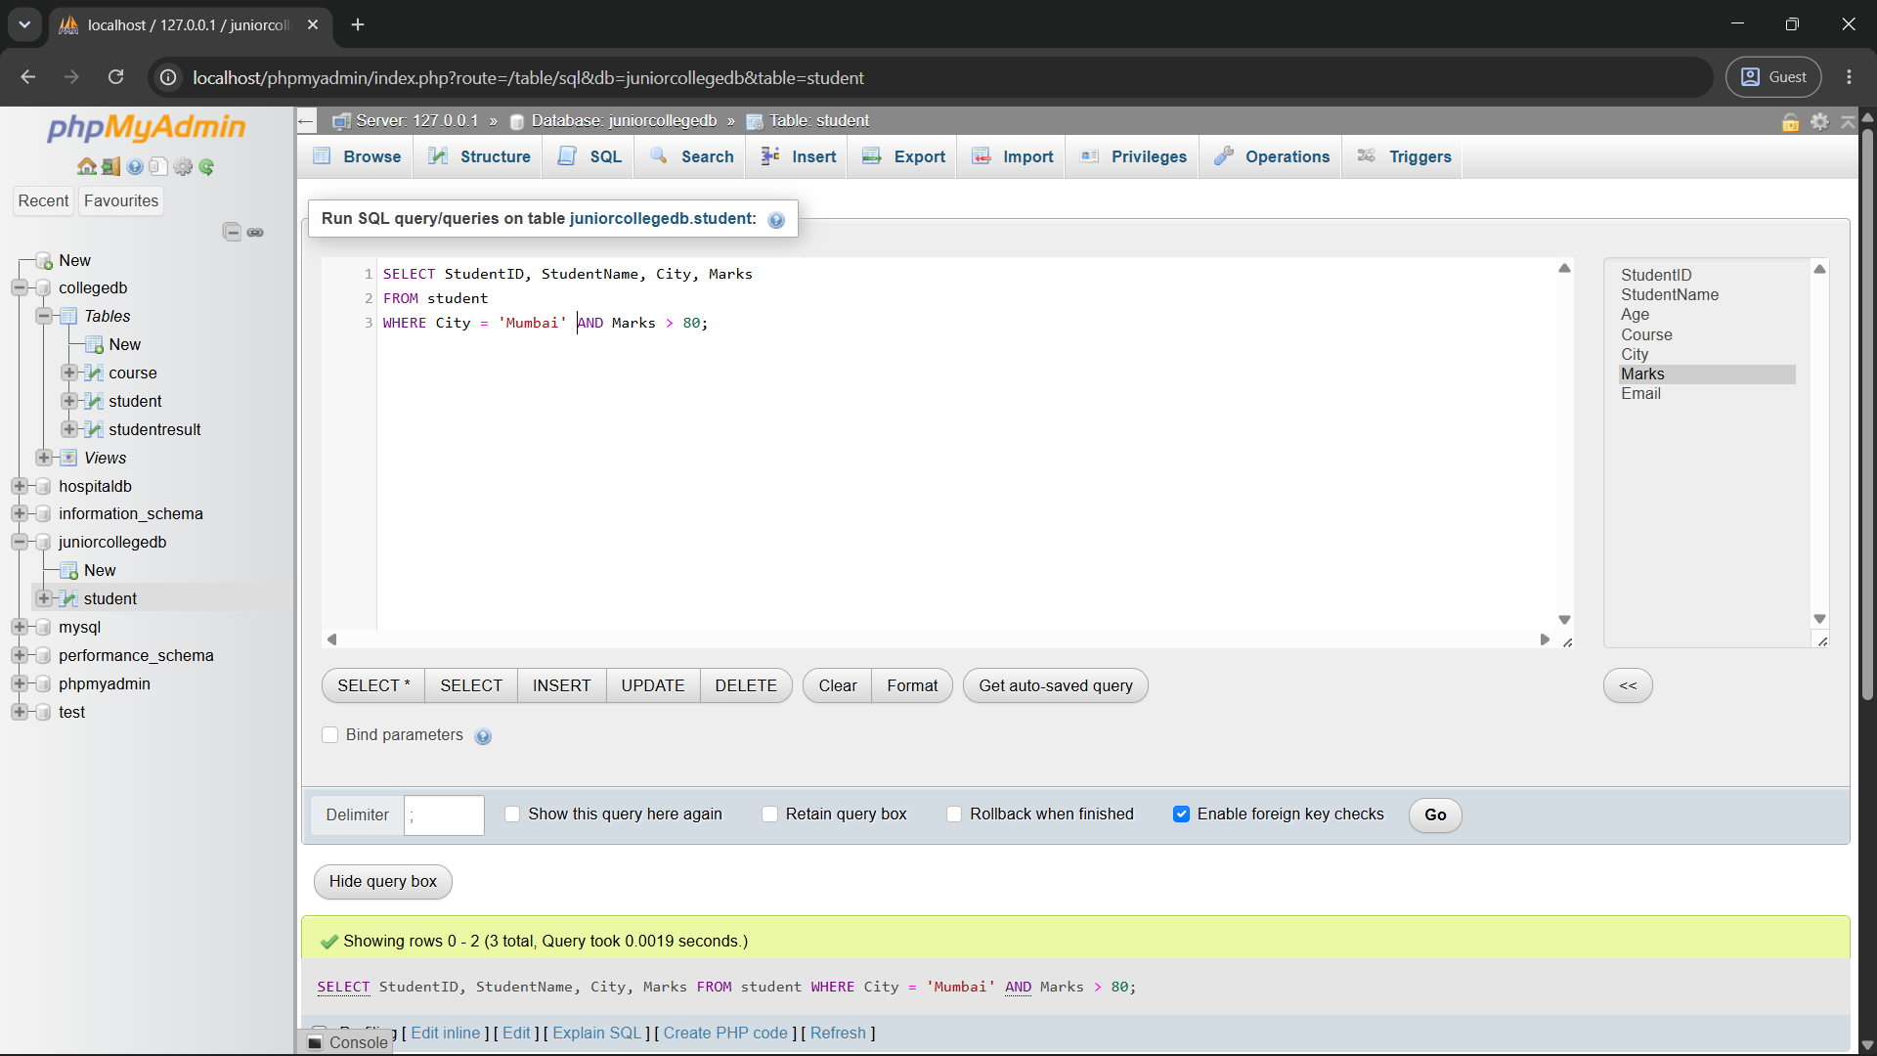

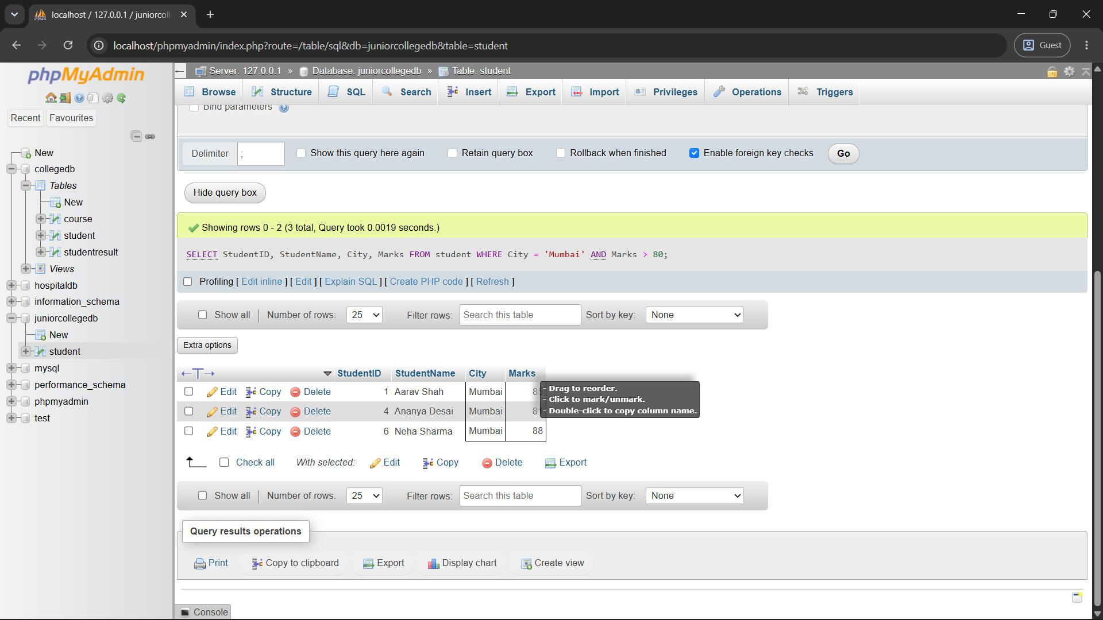

Q3) Write a MySQL query to display students who belong to either Pune or Nashik.

Use the OR operator and display the following columns:

Column
StudentName
Course
City

QUERY:

SELECT StudentName,Course,City
FROM Student
WHERE City = 'Pune' OR City = 'Nashik';

OUTPUT:

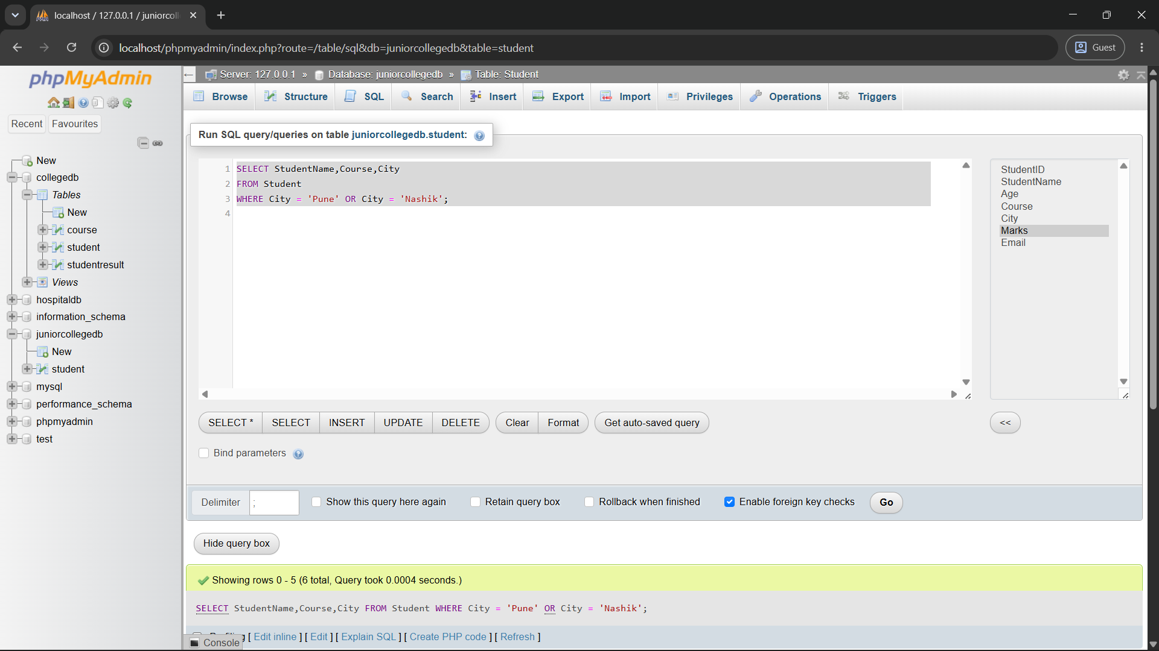
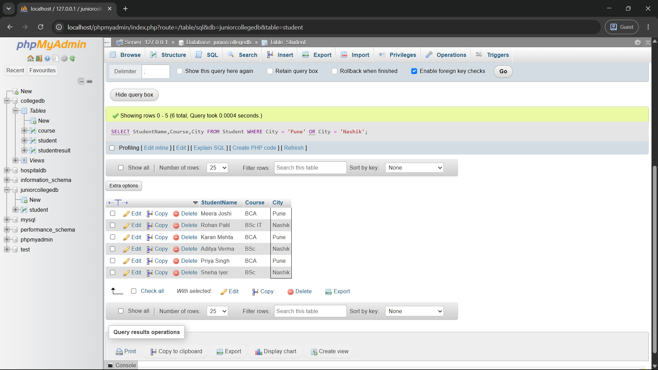

Q4) Write a MySQL query to display students whose marks are between 70 and 90.
Use the BETWEEN operator and display:
Column
StudentName
Marks

QUERY:
SELECT StudentName,Marks
FROM student
WHERE Marks BETWEEN 70 AND 90;

OUTPUT:
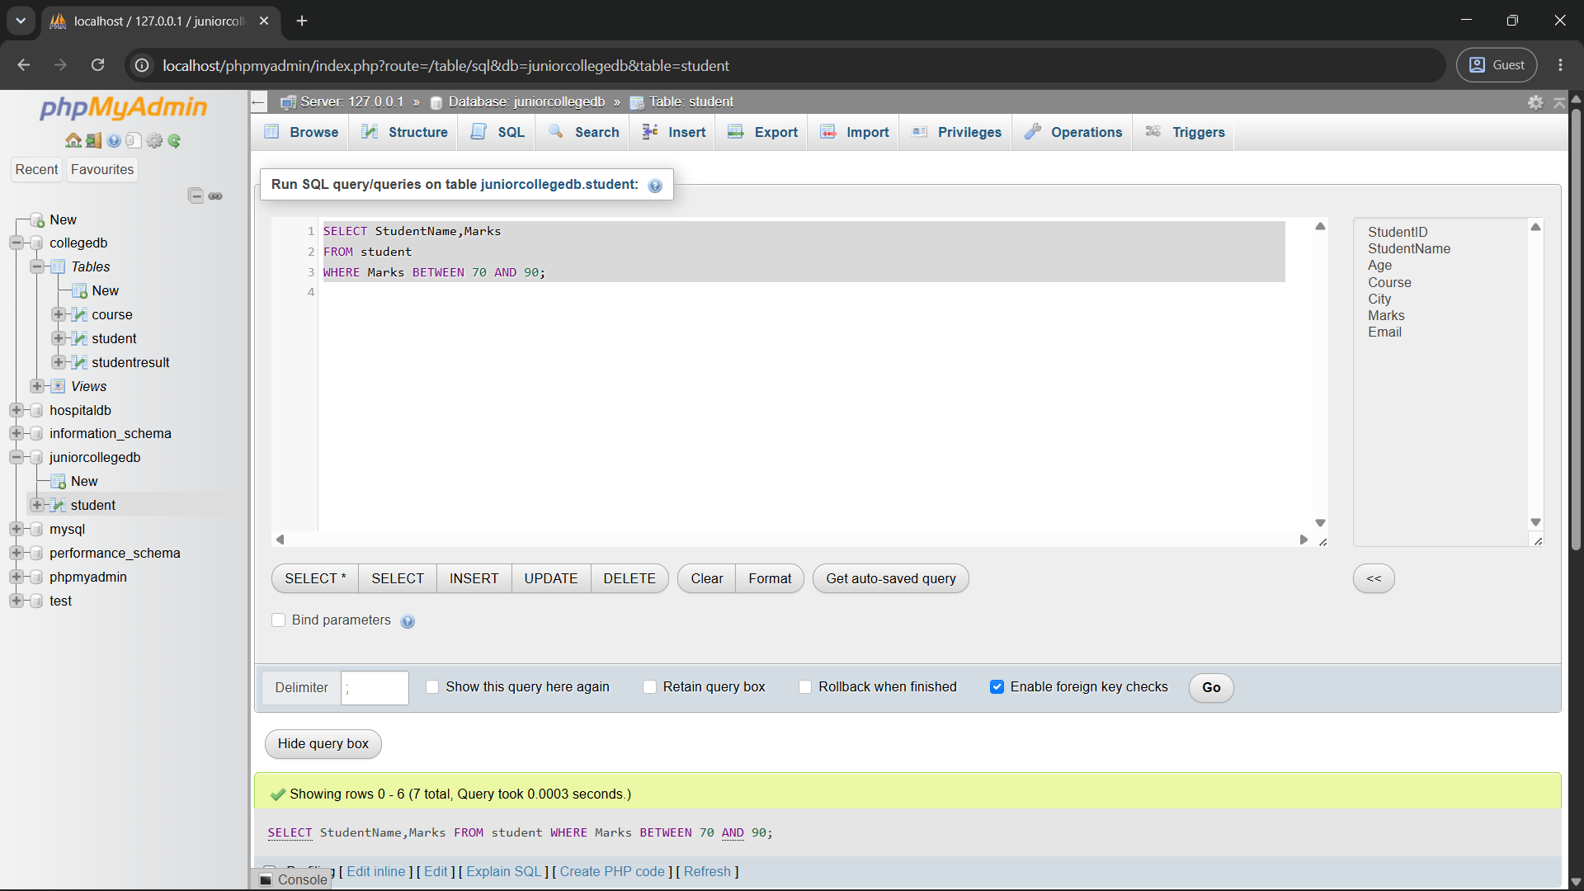
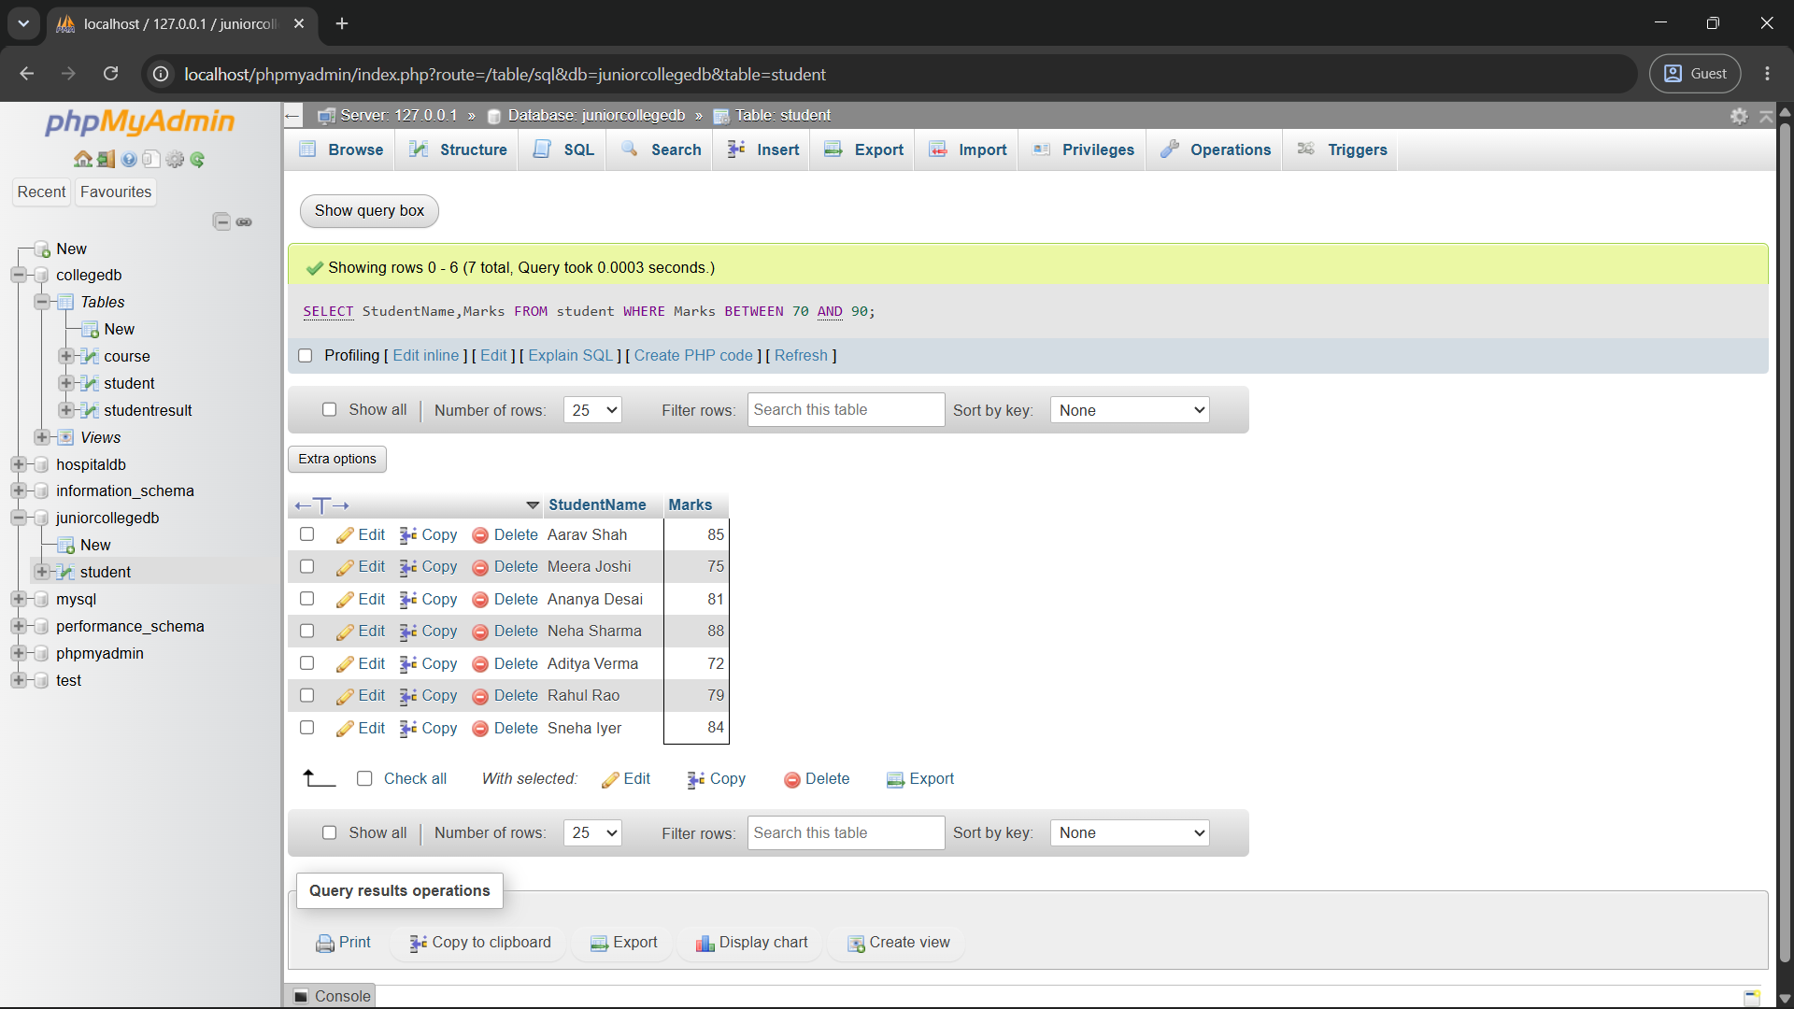

Q5) Write a MySQL query to display students whose names start with the letter A.
Use the LIKE operator and display:
Column
StudentID
StudentName

QUERY:
SELECT StudentID,StudentName
FROM Student
WHERE StudentName LIKE 'A%';

OUTPUT:
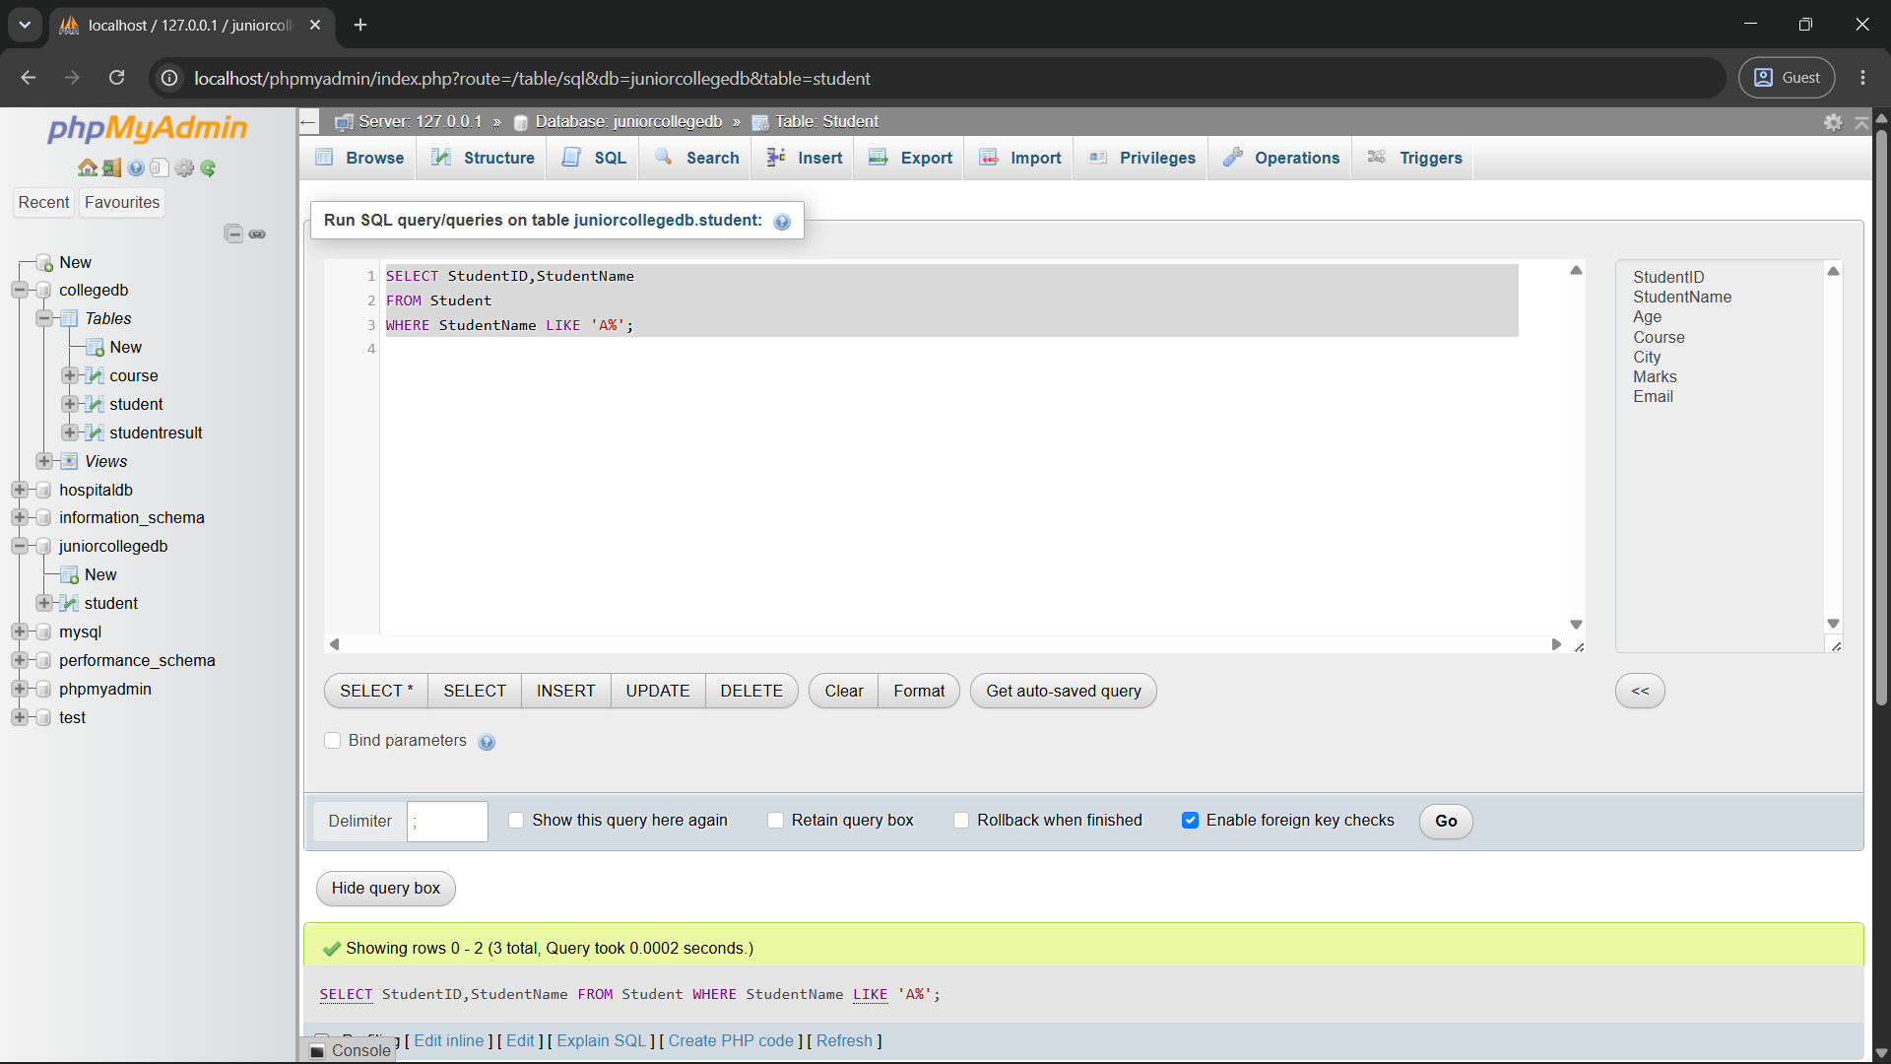

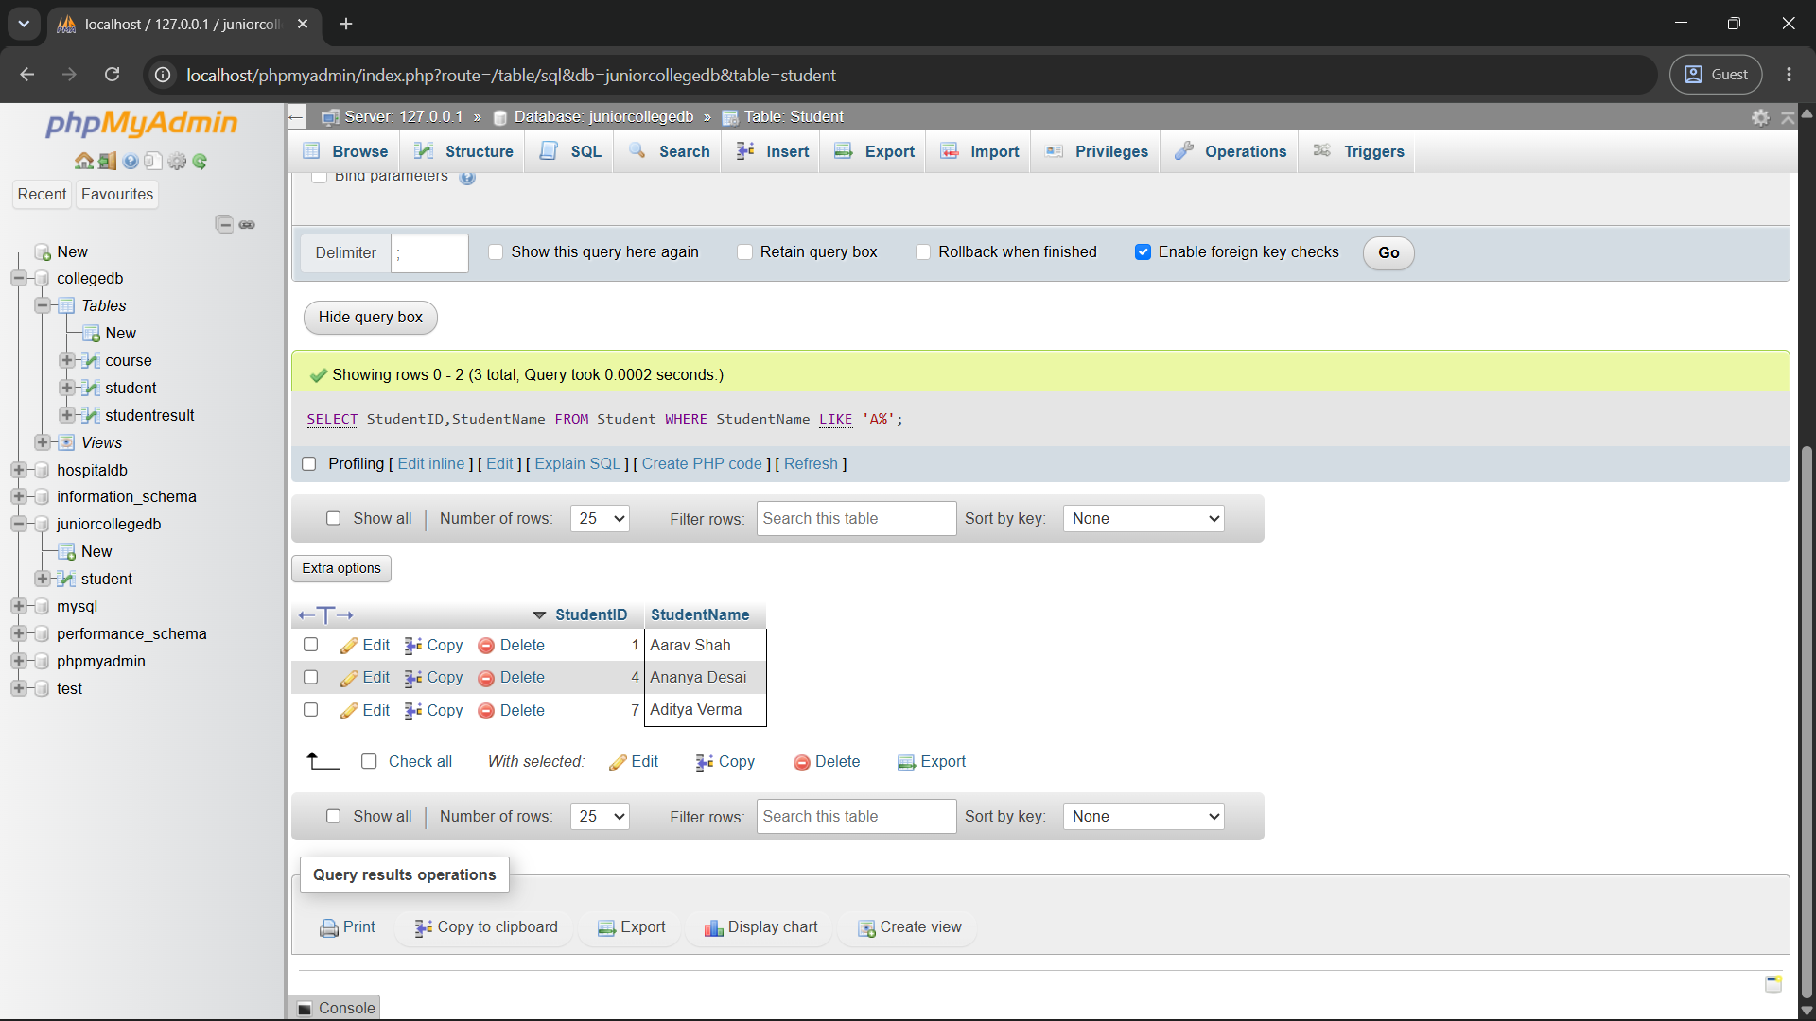

Q6) Write a MySQL query to display students whose email address is missing.
Use the IS NULL operator and display:
Column
StudentID
StudentName
Email

QUERY:
SELECT StudentID,StudentName,Email
FROM student
WHERE Email IS NULL;

OUTPUT:
